
Name:_________________________________________

Teacher: _______________________________________

MATHEMATICS – PATHWAY 1

YEAR 10 EXAM

SEMESTER TWO 2021

Section Two: Resource Allowed

TIME ALLOWED FOR THIS PAPER
Reading time before commencing 5 minutes.
Working time for paper 55 minutes.

MATERIAL(S) REQUIRED / RECOMMENDED FOR THIS PAPER
TO BE PROVIDED BY THE SUPERVISOR:
This Question / Answer Booklet
Formula Sheet
TO BE PROVIDED BY THE CANDIDATE:
Standard items: pens, pencils, pencil sharpener, eraser, correction fluid, ruler, highlighters.

Special items: Calculator, 1 x A4 sheet of notes.

Important note to candidates:
No other items may be used in this section of the examination. It is your responsibility to ensure that you do not have any unauthorised notes or other items of a non-personal nature in the examination room. If you have any unauthorised material with you, hand it to the supervisor before reading any further.

Instructions to candidates
- Candidates are to remain seated during the exam and are not allowed to talk to other candidates.
- Mobile phones are not to be used at all during the exam.
- Students who fail to follow examination rules will be removed and dealt with in accordance to the schools policy.

Write your answers in the spaces provided in this Question/Answer Booklet. Spare pages are included at the end of this booklet. They can be used for planning your responses and/or as additional space if required to continue an answer.
- Planning: If you use spare pages for planning, indicate this clearly at the top of the page
- Continuing an answer: If you need the space to continue an answer, indicate in the original answer space where the answer is continued, i.e. give the page number. Fill in the number of the question(s) that you are continuing to answer at the top of the page.

Show all your working clearly. Your working should be sufficient to allow your answers to be checked readily and for marks to be awarded for reasoning. Incorrect answers given without supporting reasoning cannot be allocated any marks. For any question or part question worth more than two marks, valid working or justification is required to receive full marks. If you repeat an answer to any question, ensure that you cancel the answer you do not wish to have marked.

Use a blue or black pen only, except with diagrams where you should use pencil.

Question | Out of | Mark
7 | 5
8 | 5
9 | 4
10 | 12
11 | 6
12 | 3
13 | 7
14 | 5
15 | 7
TOTAL | 54
 | Mark
Percentage

Question 7: (5 marks)
- On the grid below sketch the circle $x^{2}+y^{2}=4$ [1]

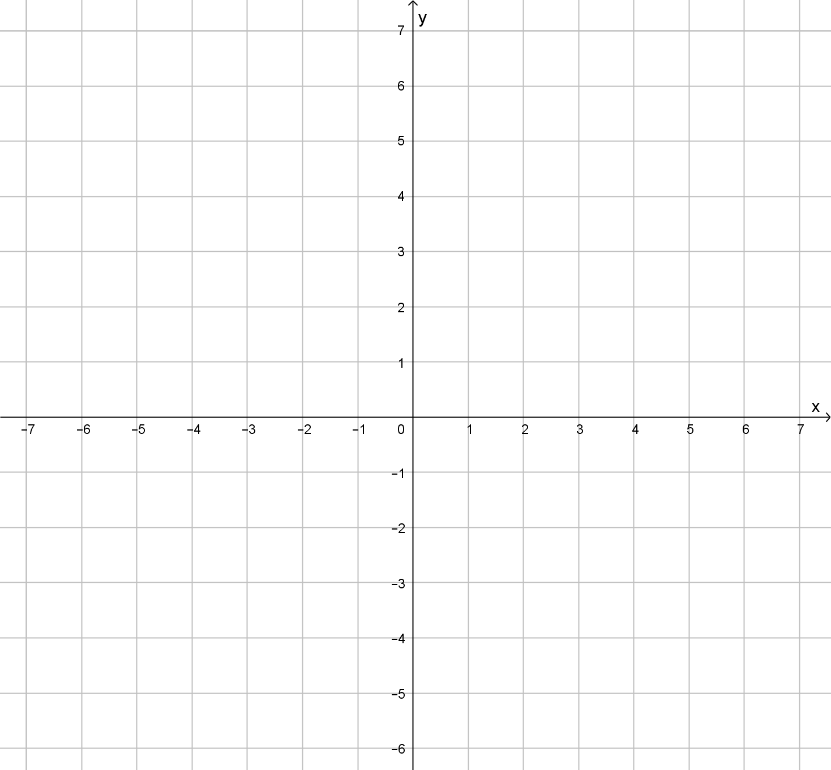
- This circle is translated 4 units left and 3 units down. Sketch this circle on the gird. [2]

- What is the equation of this new circle? [2]

Question 8 [5 marks]
John wants to invest $8500 for 10 years. He has two investment options
1. Earning 4.2% p.a. Interest compounded annually.
2. Earning 5% p.a. simple interest each year.
Which investment should he choose? Justify your answer.

Question 9: [4 marks]
A ship leave Fremantle port on a bearing of 300º and continues on this course for 250km. It then travels due north for another 475km. How far directly from the origin point is the ship now? (Round to the nearest 10km)

Question 10: (12 marks)
Consider the function $y=2^{x}$
- Find the value$y$ when $x=2$.

(1 mark)
- Find the value of $y$ when $x=-2$.

(1 mark)
- Describe what happens to the values of $y$ as the values of $x$ increase.
(1 mark)
- Can $y$ ever be negative? Why?
(2 marks)
- In the grid below sketch $y=3^{x}$
(3 marks)
- On the same axes sketch $y={-3}^{x+2}$ Describe how the graph is transformed
(4 marks)
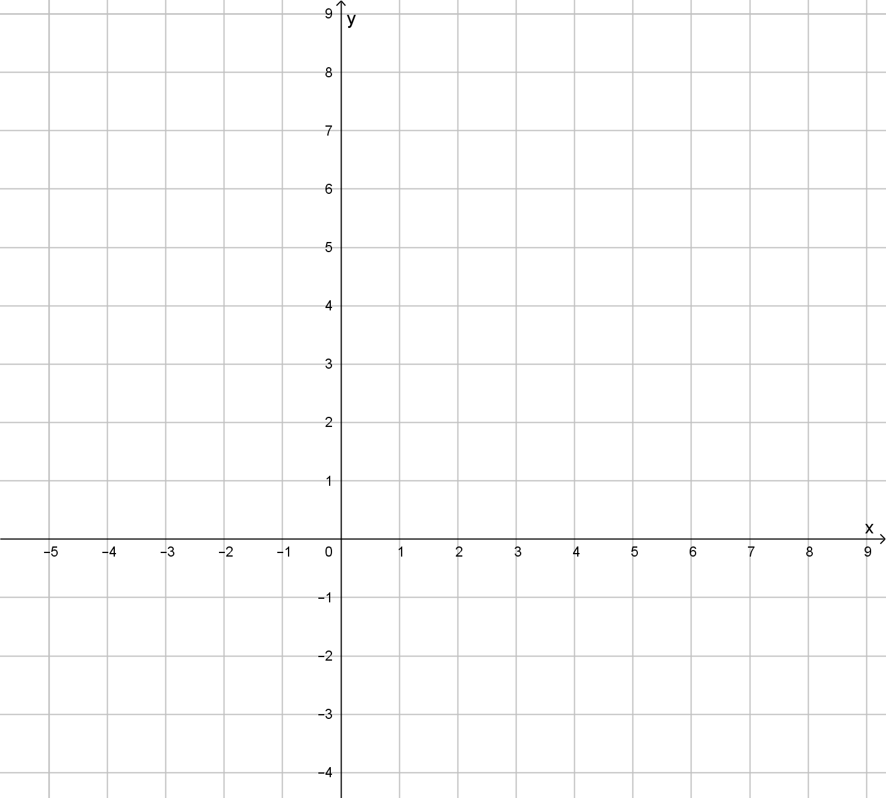

Question 11: (6 Marks)
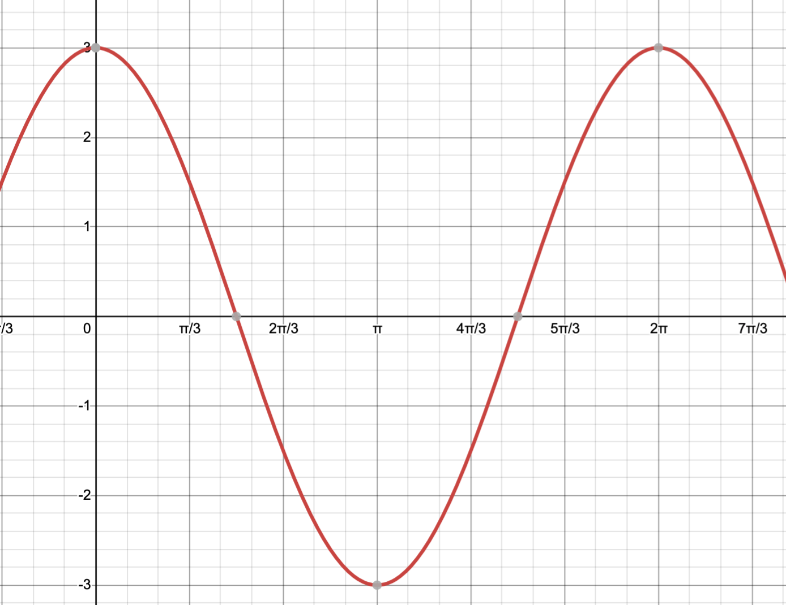
- Determine the equation of the wave on the graph below [2]

- On the axis above, draw the graph of y=2sin(2x) ensuring you pass through all key points [4]

Question 12: (3 marks)
Calculate the value of y.
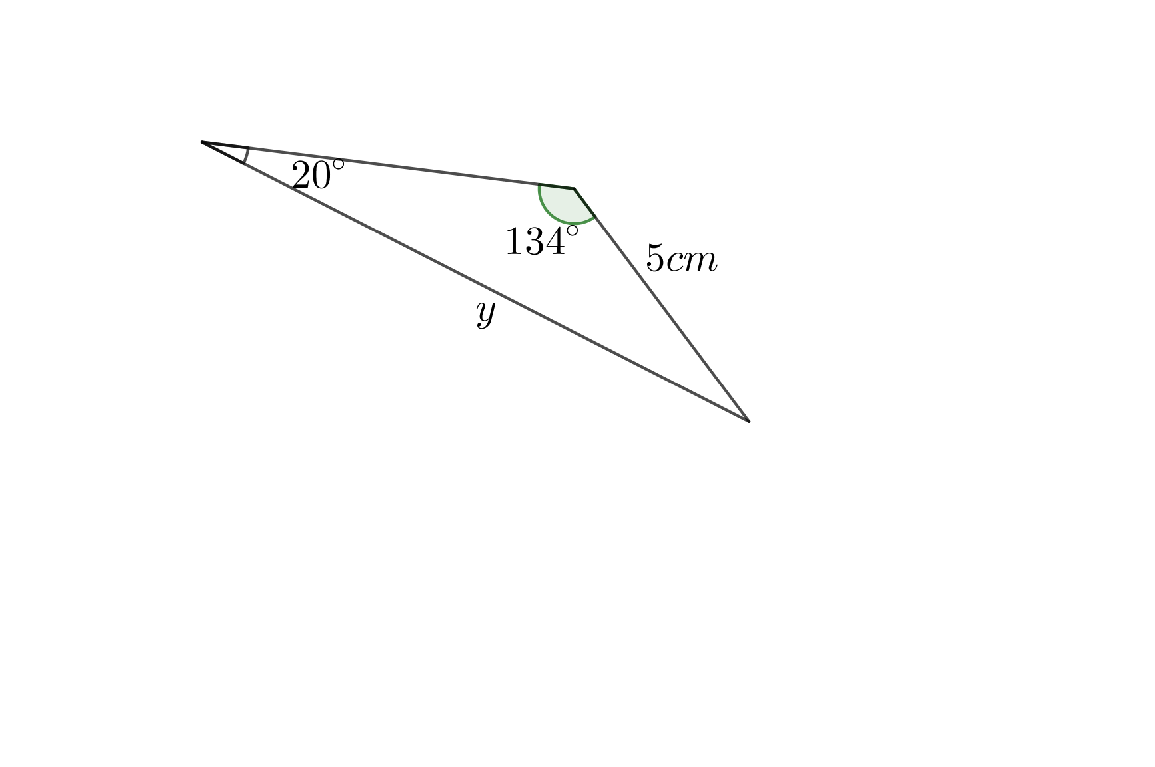

Question 13: (7 marks)
From the top of a vertical cliff, a boat is spotted 750 m out at sea. The angle of depression of the boat from the top of the cliff is 28°.
- Draw a fully labelled diagram of this situation. [1]

- Determine the height of the cliff, to the nearest meter. [3]

- After the boat has moved a further 300 metres directly away from the cliff, what has the angle decreased to? [3]

Question 14: (5 marks)
Determine the surface area and volume of the cake tin below.

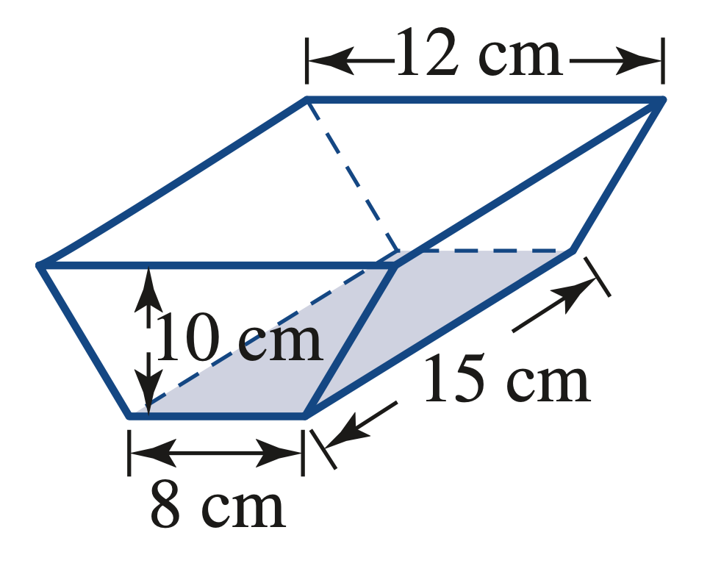

$10.2$cm

Question 15: (7 Marks)
Samantha is 50 m due north of a Radio tower. The top of the tower is at an angle of elevation of 41° from her observation point. Her partner Amy is at another observation point, due east of the tower. Amy’s angle of elevation of the top of the tower is 29°. Find:
- the height of the tower [2]

(b) hence, find the distance between Samantha and Amy to the nearest metre. [5]

END OF SECTION 2

